**Body image and social media**

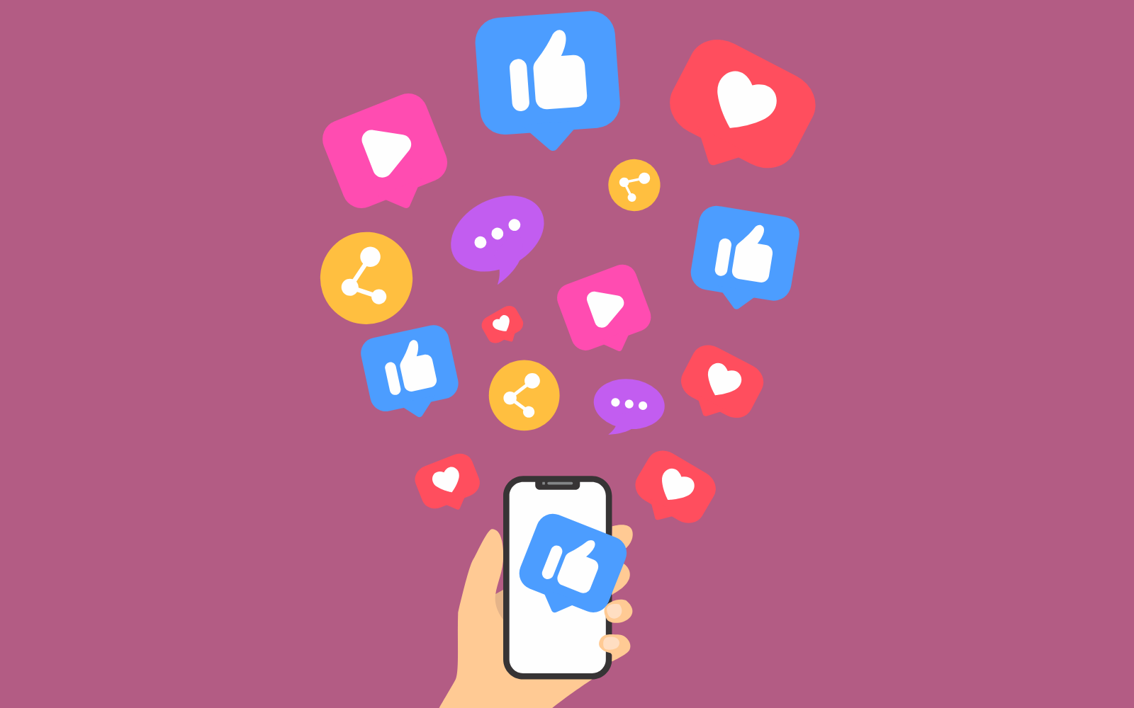

The internet and social media have brought some great benefits, but they also pose some problems too.

In an increasing online and digital world it can be hard to stay positive about the way we look.

Body image is how we think and feel about our body.

Self-confidence is liking and taking care of ourselves, feeling worthwhile, believing in ourselves, and knowing what we do well.

Body image and self-confidence start developing right from when we are babies and affected by things like our relationships, our experiences and the world around us.

**What does positive body image and self-confidence look like?**

* Accepting and appreciating our body
* Knowing that we deserve to be cared for
* Caring for our body to keep it strong and healthy
* Having a broad idea about what looking good means
* Being able to talk about our weight and not feeling ashamed
* Asking for help when we need it
* Trying new things and trying again if they don’t go as planned
* Wearing what we want to
* Facing challenges rather than avoiding them
* Thinking more about what our body does for us and its unique qualities than what it looks like.

**Where does social media fit in?**

More than 8 out of 10 people in the UK regularly use online social media. The average person spends around two and a half hours per day using sites such as Instagram, TikTok and Facebook,

Videos, images and photos are a huge part of social media. In fact we can view 100s of them every day. But what effect does this have on our body image and confidence?

Many users find helpful information and inspiration for a healthy lifestyle on social media. For others social media can be platform for body positivity, support and encouragement.

But research shows that social media can also have a harmful impact on our body image and confidence.

**How can social media negatively impact on how we feel?**

*Unhelpful influencers*

The online world is full of highly edited, filtered and even AI-generated images of celebrities, fashion and fitness models who use social media to promote themselves as well as their products and services.

These can send us the message that only certain unrealistic body types, appearances and lifestyles are acceptable.

They can also promote expensive diet or exercise plans, medications or supplements which promise a ‘quick fix’ but have very little science behind them.

*Unfair comparisons*

Research shows that people who spend more time viewing social media selfies from friends and acquaintances have more negative thoughts about their own lives and bodies.

Even though we know that only the best shots get posted, our brains are wired to compare ourselves unfairly.

*Riding the selfie rollercoaster*

Taking, perfecting and posting images of ourselves and waiting for reassurance from other people’s likes and comments can be an emotional rollercoaster.

Research has shown that people who post more selfies tend to think more about what their bodies look like and are more dissatisfied with their appearance.

*Online bullying*

Around half of young people report having experienced cyber-bullying when online.

Most common were hurtful comments about their appearance.

**Tips for feeling good about your body in a digital world**

1. Change for the right reasons: If you decide to try and lose weight, do it because you want to be healthy and care for your body and mind, not just to look a certain way.

2. Remember the amazing things our bodies can do, at all sizes. Get into the habit of making time

each evening to thank your body for what it has done for you that day.

3. Practise saying “well done” to yourself. Recognise progress on things you’ve worked hard on, like reaching your healthy eating goals today, whether or not you see effects on the scales.

4. Be mindfully active: We are more likely to keep doing things if we enjoy them. Try different activities and discover what you find fun, energising and makes you feel good afterwards.

5. Remember no body is perfect. What you see online, on social media and on TV uses lighting, photo-editing, AI and more to make people look different from in real life.

6. Look for the whole picture: Nearly everyone only posts their best moments and images online. Posting more selfies may actually be a sign that a friend is struggling with their body image and self-confidence at the moment.

7. Be a social media detective: Ask yourself ‘what has this person got to gain from making me believe their life is a certain way?’ Looking at the source of posts and what is tagged can help find out if someone is being sponsored or paid to promote an appearance, lifestyle or product. Rave reviews of medications or products promising a ‘quick fix’ can be faked or can be from a few ‘happy customers’ only, not the majority.

8. Shape your socials: Pause to notice how you’re feeling when scrolling or posting on social media. Follow accounts that make you feel good and don’t be afraid to unfollow others! Think what other topics you could add into your feed so that it’s not all photos and videos of people. Screen time limits and social media detoxes can help our stress levels, improve sleep and body image, and help us feel more connected to the world and others around us.

9. Be kind to others: Everyone deserves to feel good and be treated like a human, whatever their body size, shape or ability. Be part of building positive online communities and be kind when posting, viewing, commenting and sharing online.

10. Be kind to yourself: On a day when it’s hard to keep up healthy changes or self-critical thoughts pop up, try to remember “this feeling will pass”, “tomorrow is a new day”, and “I’m doing the best I can”.

**Find out more.**

[Body image and mental health](https://www.mentalhealth.org.uk/explore-mental-health/body-image)

[What is self-esteem? - Mind](https://www.mind.org.uk/information-support/types-of-mental-health-problems/self-esteem/about-self-esteem/)

<https://www.nhs.uk/mental-health/self-help/tips-and-support/raise-low-self-esteem/>

[Online safety advice for parents and carers](https://www.internetmatters.org/)

[Checklist for spotting misinformation online](https://sharechecklist.gov.uk/)

[Body Image: Difference is What Makes Us Unique - Beat (beateatingdisorders.org.uk)](https://www.beateatingdisorders.org.uk/your-stories/difference-makes-us-unique/)

[King University. The link between social media and body image.](https://online.king.edu/news/social-media-and-body-image/)