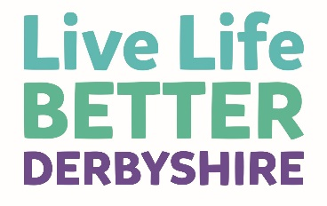
Support from others
Support from other people can be an important part of making healthy lifestyle changes that last.
Support from friends and family can improve weight loss, increase physical activity levels and lead to more long-term healthy behaviour changes.
You’ve been given this leaflet by someone close to you, who wants to support you to support them on their journey.
We know it’s sometimes hard to know the best thing to say or do, so here are some simple ideas you might want to try.
How can you support someone with their healthy living journey?
- Listen with empathy. For example, ‘it sounds like it’s been a tough week for you’.
- Ask how you can be supportive. For example ‘what can I do to support you this week?’
- Accept that you don’t need to ‘fix’ or ‘solve’ or have all the answers, everyone’s different and different things will help different people.
- Try to make some healthy lifestyle changes together. For example, maybe you could try different snacks when you next meet up.
- Try out new healthy foods or physical activity together. For example, perhaps you could send photos of new healthy recipes you’ve tried out.
- Show an interest in what is being learnt about on the programme.
- Consider treats and gifts that aren’t food-based, for example, cards or outings.
- Listen when someone says ‘no thank you’ or ‘yes please’.
- Be positive and encouraging for example, ‘that’s really great’.
- When being positive about progress, try to focus more on health and the hard work that’s been put in, rather than appearances.
- And remind the person you’re supporting (and yourself as a supporter) that slip ups are normal, they’re to be expected, and are a great way to learn.

Your support really can make a massive difference, so thank you for taking the time to read this leaflet.
If you would like more ideas or would like to learn more about Live Life Better Derbyshire, you are welcome to attend sessions along with your family member or friend.

